**HOTEL RESERVATION SYSTEM**

by

R.B.ADVAITHBARATH 18BCE1061

R.VIGNESHWARAN 18BCE1347

JACK NICKSON 18BCE1098

A project report submitted to

**Prof. Maheshwari S**

**SCHOOL OF COMPUTER SCIENCE ENGINEERING**

in partial fulfilment of the requirements for the course of

**CSE3002-** **Internet and Web Programming**

in

**B.Tech. COMPUTER SCIENCE AND ENGINEERING**



**VIT CHENNAI**

**Vandalur – Kelambakkam Road**

**Chennai – 600127**

**JUNE 2020**

**BONAFIDE CERTIFICATE**

Certified that this project report entitled “**HOTEL RESERVATION SYSTEM”** is a Bonafede work of **R.Vigneshwaran** who carried out the Project work under my supervision and guidance for **CSE3002-** **Internet and Web Programming**

**Prof. Maheshwari S**

Assistant Professor

School of Computer Science Engineering (SCSE),

VIT Chennai

Chennai – 600 127.

**BONAFIDE CERTIFICATE**

Certified that this project report entitled “**HOTEL RESERVATION SYSTEM”** is a Bonafede work of **R.B.Advaithbarath** who carried out the Project work under my supervision and guidance for **CSE3002-** **Internet and Web Programming**

**Prof. Maheshwari S**

Assistant Professor

School of Computer Science Engineering (SCSE),

VIT Chennai

Chennai – 600 127.

**BONAFIDE CERTIFICATE**

Certified that this project report entitled “**HOTEL RESERVATION SYSTEM”** is a Bonafede work of **Jack Nickson** who carried out the Project work under my supervision and guidance for **CSE3002-** **Internet and Web Programming**

**Prof. Maheshwari S**

Assistant Professor

School of Computer Science Engineering (SCSE),

VIT Chennai

Chennai – 600 127.

**ACKNOWLEDGEMENT**

We wish to express our sincere thanks and deep sense of gratitude to our project guide, **Prof. Maheshwari S,** Assistant Professor, School of Computer Science Engineering, for his consistent encouragement and valuable guidance offered to us in a pleasant manner throughout the course of the project work.

We are extremely grateful to **Dr. Jagadeesh Kannan**, Dean of the School of Computer Science Engineering, VIT Chennai, for extending the facilities of the School towards our project and for his unstinting support.

We express our thanks to our Head of the Department **Dr. Justus S** for his support throughout the course of this project.

We also take this opportunity to thank all the faculty of the School for their support and their wisdom imparted to us throughout the course.

We thank our parents, family, and friends for bearing with us throughout the course of our project and for the opportunity they provided us in undergoing this course in such a prestigious institution.

**TABLE OF CONTENTS**

|  |  |  |
| --- | --- | --- |
| **SERIAL NO.** | **NAME** | **PAGE NO.** |
|  | ACKNOWLEDGEMENT | 5 |
|  |  |  |
| 1 | OBJECTIVE | 7 |
|  |  |  |
| 2. | REASON FOR THIS PROJECT | 7 |
| 3. | FEATURES | 8 |
|  |  |  |
| 4. | HOW IT IS DIFFERENT FROM EXISTING MODEL |  |
|  |  |  |
| 5 | PROBLEM THAT WE HAD FACED DURING THE COURSE OF PROJECT | 10 |
|  |  |  |
| 6 | SOFTWARE IMPLEMENTATION | 10 |
|  |  |  |
| 7 | SAMPLE CODE | 11 |
|  |  |  |
| 8 | OUTPUT | 51 |
|  |  |  |
| 9 | CONCLUSION | 55 |
|  |  |  |
| 10 | REFERENCES | 55 |

**1.Objective :**

1. In this project we have aimed to develop a hotel reservation system website using html,css,javascript , bootstrap on the front end part and php ,mysql for the back end part of this project
2. It will have two portals , namely for the admin and another one for the user to reserve rooms
3. The project will use sql databases centrally to store details of all customers , reservation details , hotel details ,etc.
4. To provide an easy , fresh and pleasant user interface for customers to book their required hotel rooms and get information about the same on availability, features , prices and other necessary details.
5. Admins should easily confirm their upcoming bookings and manage their room availabilities and existing customers.

**2.Reason for this project**

We had an idea to build this project because , we felt that customers must be able to easily book their hotel rooms , by having a perspective of how the actual hotel rooms look. To achieve this , we have a huge gallery of photos for each type of room , and the superior facilities provided by the hotel.

Also booking it online drastically saves the customers time rather than doing it by physically coming to the hotel . Also payment becomes easier for the users. Considering the admin point of view , it simplifies their work of managing all existing and future customers. They can simply approve bookings , see availabilities of rooms , and have a record of all these details , accessible any time from any place . It makes the management more efficient and easier for high level operators to oversee their business and gather statistics.

**3.Features :**

1. Admin and user portal to manage hotel bookings and make them respectively
2. User portal has a wide range of gallery pictures to make the users know various amenities in it
3. User login to have a record of his/her room reservation details managed by server sessions
4. Hotel address , contact details are present on site, and users can choose type of room ,price of room, food services needed , duration of stay , etc . and also view status of their bookings
5. On admin side they can see full details on existing bookings as well as update statuses of pending bookings
6. Graph and statistical data are shown to admin to see their overall bookings throughout the year
7. See all their present types of rooms in the hotel , and note how many of them are occupied and how many are available .
8. Create new users to control admin account also with login credentials for each of them

**4. How its different from existing models**

1. More simplified way of approach than existing websites , which take in too much amount of customer data , purposefully store those in their own servers and misuse them for targeted advertisement
2. Short number of steps and minimal time taken for users to book the rooms and avail the receipt
3. Existing websites take commission from hotels on each booking done through the site , but no such activity is done on this website.
4. Statistical graphs and reports are available to admins in their portal about their received bookings
5. Present users can create new accounts to give new account access to other hotel staffs
6. This model can be used also for low level hotels to support them as most websites partner with above middle range hotels.

**5. Problem that we had faced during the course of project**

1. Cache data must be cleared everytime for the changes made in CSS or Bootstrap. So we often switch between browser like chrome or edge
2. We notice some font misalignment during integrating our websites with bootstraps
3. Reported inaccuracies in statistics and graph wich have been fixed.
4. <Mail to> command isn’t working properly according to the functioning of the website
5. Some sql data isn’t synced properly to the invoice when executing for the first time.

**6.** **Software implementation**

**OS:** WINDOWS 10

**EDITING SOFTWARE:** VISUAL STUDIO CODE

**WEB BROWSER USED:** GOOGLE CHROME, MICROSOFT EDGE

**FRONT END:** HTML,CSS,JAVA-SCRIPT,BOOTSTRAP

**BACK END:** PHP,JAVA-SCRIPT

**7.** **Sample Code**

**HTML CODE MAIN PAGE**

<?php

include('db.php');

?>

<!DOCTYPE html>

<html lang="en">

<head>

<title>TAJ COROMANDEL</title>

<link href="css/bootstrap.css" rel="stylesheet" type="text/css" media="all" />

<link href="css/font-awesome.css" rel="stylesheet">

<link rel="stylesheet" href="css/chocolat.css" type="text/css" media="screen">

<link href="css/easy-responsive-tabs.css" rel='stylesheet' type='text/css'/>

<link rel="stylesheet" href="css/flexslider.css" type="text/css" media="screen" property="" />

<link rel="stylesheet" href="css/jquery-ui.css" />

<link href="css/style.css" rel="stylesheet" type="text/css" media="all" />

<script type="text/javascript" src="js/modernizr-2.6.2.min.js"></script>

<!--fonts-->

<link href="//fonts.googleapis.com/css?family=Oswald:300,400,700" rel="stylesheet">

<link href="//fonts.googleapis.com/css?family=Federo" rel="stylesheet">

<link href="//fonts.googleapis.com/css?family=Lato:300,400,700,900" rel="stylesheet">

<!--//fonts-->

</head>

<body>

<!-- header -->

<div class="banner-top">

            <div class="social-bnr-agileits">

                <ul class="social-icons3">

                                <li><a href="https://www.facebook.com/" class="fa fa-facebook icon-border facebook"> </a></li>

                                <li><a href="https://twitter.com/" class="fa fa-twitter icon-border twitter"> </a></li>

                                <li><a href="https://plus.google.com/u/0/" class="fa fa-google-plus icon-border googleplus"> </a></li>

                            </ul>

            </div>

            <div class="contact-bnr-w3-agile">

                <ul>

                    <li><i class="fa fa-envelope" aria-hidden="true"></i><a href="mailto:taj@coromandel.com">TAJ@COROMANDEL.COM</a></li>

                    <li><i class="fa fa-phone" aria-hidden="true"></i>+044 6600 2827</li>

                    <li class="s-bar">

                        <div class="search">

                            <input class="search_box" type="checkbox" id="search_box">

                            <label class="icon-search" for="search_box"><span class="glyphicon glyphicon-search" aria-hidden="true"></span></label>

                            <div class="search_form">

                                <form action="#" method="post">

                                    <input type="search" name="Search" placeholder=" " required=" " />

                                    <input type="submit" value="Search">

                                </form>

                            </div>

                        </div>

                    </li>

                </ul>

            </div>

            <div class="clearfix"></div>

        </div>

    <div class="w3_navigation">

        <div class="container">

            <nav class="navbar navbar-default">

                <div class="navbar-header navbar-left">

                    <button type="button" class="navbar-toggle collapsed" data-toggle="collapse" data-target="#bs-example-navbar-collapse-1">

                        <span class="sr-only">Toggle navigation</span>

                        <span class="icon-bar"></span>

                        <span class="icon-bar"></span>

                        <span class="icon-bar"></span>

                    </button>

                    <h1><a class="navbar-brand" href="index.php">TAJ <span>COROMANDEL</span><p class="logo_w3l_agile_caption">Your Dreamy Resort</p></a></h1>

                </div>

                <!-- Collect the nav links, forms, and other content for toggling -->

                <div class="collapse navbar-collapse navbar-right" id="bs-example-navbar-collapse-1">

                    <nav class="menu menu--iris">

                        <ul class="nav navbar-nav menu__list">

                            <li class="menu__item menu__item--current"><a href="" class="menu__link">Home</a></li>

                            <li class="menu__item"><a href="#about" class="menu__link scroll">About</a></li>

                            <li class="menu__item"><a href="#gallery" class="menu__link scroll">Gallery</a></li>

                            <li class="menu__item"><a href="#rooms" class="menu__link scroll">Rooms</a></li>

                            <li class="menu__item"><a href="#contact" class="menu__link scroll">Contact Us</a></li>

                        </ul>

                    </nav>

                </div>

            </nav>

        </div>

    </div>

<!-- //header -->

        <!-- banner -->

    <div id="home" class="w3ls-banner">

        <!-- banner-text -->

        <div class="slider">

            <div class="callbacks_container">

                <ul class="rslides callbacks callbacks1" id="slider4">

                    <li>

                        <div class="w3layouts-banner-top">

                            <div class="container">

                                <div class="agileits-banner-info">

                                <h4>TAJ COROMANDEL</h4>

                                    <h3>We know what you love</h3>

                                        <p>Welcome to our hotels</p>

                                    <div class="agileits_w3layouts_more menu__item">

                <a href="#" class="menu__link" data-toggle="modal" data-target="#myModal">Learn More</a>

            </div>

                                </div>

                            </div>

                        </div>

                    </li>

                    <li>

                        <div class="w3layouts-banner-top w3layouts-banner-top1">

                            <div class="container">

                                <div class="agileits-banner-info">

                                <h4>TAJ COROMANDEL</h4>

                                    <h3>Stay with friends & families</h3>

                                        <p>Come & enjoy precious moment with us</p>

                                    <div class="agileits_w3layouts_more menu__item">

                <a href="#" class="menu__link" data-toggle="modal" data-target="#myModal">Learn More</a>

            </div>

                                </div>

                            </div>

                        </div>

                    </li>

                    <li>

                        <div class="w3layouts-banner-top w3layouts-banner-top2">

                            <div class="container">

                                <div class="agileits-banner-info">

                                <h4>TAJ COROMANDEL</h4>

                                <h3>want luxurious vacation?</h3>

                                        <p>Get accommodation today</p>

                                    <div class="agileits_w3layouts_more menu__item">

                                            <a href="#" class="menu__link" data-toggle="modal" data-target="#myModal">Learn More</a>

                                        </div>

                                </div>

                            </div>

                        </div>

                    </li>

                </ul>

            </div>

            <div class="clearfix"> </div>

            <!--banner Slider starts Here-->

        </div>

            <div class="thim-click-to-bottom">

                <a href="#about" class="scroll">

                    <i class="fa fa-long-arrow-down" aria-hidden="true"></i>

                </a>

            </div>

    </div>

    <!-- //banner -->

<div class="modal fade" id="myModal" tabindex="-1" role="dialog">

                        <!-- Modal1 -->

                            <div class="modal-dialog">

                            <!-- Modal content-->

                                <div class="modal-content">

                                    <div class="modal-header">

                                        <button type="button" class="close" data-dismiss="modal">&times;</button>

                                        <h4>TAJ  <span>COROMANDEL</span></h4>

                                        <img src="images/01.jpg" alt=" " class="img-responsive">

                                        <h5>We know what you love</h5>

                                        <p>Providing guests unique and enchanting views from their rooms with its exceptional amenities, makes Star Hotel one of bests in its kind.Try our food menu, awesome services and friendly staff while you are here.</p>

                                    </div>

                                </div>

                            </div>

                        </div>

<!-- //Modal1 -->

<div id="availability-agileits">

<div class="col-md-12 book-form-left-w3layouts">

    <a href="admin/reservation.php"><h2>ROOM RESERVATION</h2></a>

</div>

            <div class="clearfix"> </div>

</div>

<!-- banner-bottom -->

    <div class="banner-bottom">

        <div class="container">

            <div class="agileits_banner_bottom">

                <h3><span>Experience a good stay, enjoy fantastic offers</span> Find our friendly welcoming reception</h3>

            </div>

            <div class="w3ls_banner_bottom_grids">

                <ul class="cbp-ig-grid">

                    <li>

                        <div class="w3_grid_effect">

                            <span class="cbp-ig-icon w3_road"></span>

                            <h4 class="cbp-ig-title">MASTER BEDROOMS</h4>

                            <span class="cbp-ig-category">TAJ COROMANDEL</span>

                        </div>

                    </li>

                    <li>

                        <div class="w3_grid_effect">

                            <span class="cbp-ig-icon w3_cube"></span>

                            <h4 class="cbp-ig-title">SEA VIEW BALCONY</h4>

                            <span class="cbp-ig-category">TAJ COROMANDEL</span>

                        </div>

                    </li>

                    <li>

                        <div class="w3_grid_effect">

                            <span class="cbp-ig-icon w3_users"></span>

                            <h4 class="cbp-ig-title">LARGE CAFE</h4>

                            <span class="cbp-ig-category">TAJ COROMANDEL</span>

                        </div>

                    </li>

                    <li>

                        <div class="w3_grid_effect">

                            <span class="cbp-ig-icon w3_ticket"></span>

                            <h4 class="cbp-ig-title">WIFI COVERAGE</h4>

                            <span class="cbp-ig-category">TAJ COROMANDEL</span>

                        </div>

                    </li>

                </ul>

            </div>

        </div>

    </div>

<!-- //banner-bottom -->

<!-- /about -->

    <div class="about-wthree" id="about">

          <div class="container">

                   <div class="ab-w3l-spa">

                            <h3 class="title-w3-agileits title-black-wthree">About Our TAJ COROMANDEL</h3>

                           <p class="about-para-w3ls">Taj Coromandel, one of Chennai’s best known landmarks, presents a rich fusion of South Indian design and classic elegance. With 212 rooms and suites, the intimate five-star hotel has played host to famous political figures such as President Jimmy Carter, His Royal Highness Prince Andrew, President Bill Clinton, and the Emperor and Empress of Japan. With a location as central as Nungambakkam, you have easy access to the business district, the US Consulate, and key shopping hubs like Mahatma Gandhi Road, Express Avenue, Chennai City Centre, Khader Nawaz Khan Road and T Nagar.</p>

                           <img src="images/about1.jpg" class="img-responsive" alt="Hair Salon">

                                        <div class="w3l-slider-img">

                                            <img src="images/a2.jpg" class="img-responsive" alt="Hair Salon">

                                        </div>

                                       <div class="w3ls-info-about">

                                            <h4>You'll love all the amenities we offer!</h4>

                                        </div>

                  </div>

            <div class="clearfix"> </div>

    </div>

</div>

    <!-- //about -->

<!--sevices-->

<div class="advantages">

    <div class="container">

        <div class="advantages-main">

                <h3 class="title-w3-agileits">Our Services</h3>

           <div class="advantage-bottom">

             <div class="col-md-6 advantage-grid left-w3ls wow bounceInLeft" data-wow-delay="0.3s">

                <div class="advantage-block ">

                    <i class="fa fa-credit-card" aria-hidden="true"></i>

                    <h4>Stay First, Pay After! </h4>

                    <p>Get an opportunity to stay in our hotel.</p>

                    <p><i class="fa fa-check" aria-hidden="true"></i>Decorated room, proper air conditioned</p>

                    <p><i class="fa fa-check" aria-hidden="true"></i>Private balcony</p>

                </div>

             </div>

             <div class="col-md-6 advantage-grid right-w3ls wow zoomIn" data-wow-delay="0.3s">

                <div class="advantage-block">

                    <i class="fa fa-clock-o" aria-hidden="true"></i>

                    <h4>24 Hour Restaurant</h4>

                    <p>Can have food anytime in our restaurant</p>

                    <p><i class="fa fa-check" aria-hidden="true"></i>24 hours room service</p>

                    <p><i class="fa fa-check" aria-hidden="true"></i>24-hour Concierge service</p>

                </div>

             </div>

            <div class="clearfix"> </div>

            </div>

        </div>

    </div>

</div>

<!--//sevices-->

<!-- team -->

<!-- //team -->

<br><br>

<!-- Gallery -->

<section class="portfolio-w3ls" id="gallery">

         <h3 class="title-w3-agileits title-black-wthree">Our Gallery</h3>

                <div class="col-md-3 gallery-grid gallery1">

                    <a href="images/j1.jpg" class="swipebox"><img src="images/j1.jpg" class="img-responsive" alt="/">

                        <div class="textbox">

                        <h4>EXTERIOR DINING</h4>

                            <p><i class="fa fa-picture-o" aria-hidden="true"></i></p>

                        </div>

                </a>

                </div>

                <div class="col-md-3 gallery-grid gallery1">

                    <a href="images/j2.jpg" class="swipebox"><img src="images/j2.jpg" class="img-responsive" alt="/">

                        <div class="textbox">

                        <h4>SINGLE ROOM</h4>

                            <p><i class="fa fa-picture-o" aria-hidden="true"></i></p>

                        </div>

                </a>

                </div>

                <div class="col-md-3 gallery-grid gallery1">

                    <a href="images/j3.jpg" class="swipebox"><img src="images/j3.jpg" class="img-responsive" alt="/">

                        <div class="textbox">

                        <h4>GUEST HOUSE</h4>

                            <p><i class="fa fa-picture-o" aria-hidden="true"></i></p>

                        </div>

                </a>

                </div>

                <div class="col-md-3 gallery-grid gallery1">

                    <a href="images/j4.jpg" class="swipebox"><img src="images/j4.jpg" class="img-responsive" alt="/">

                        <div class="textbox">

                        <h4>LUXURY ROOM</h4>

                            <p><i class="fa fa-picture-o" aria-hidden="true"></i></p>

                        </div>

                </a>

                </div>

                <div class="col-md-3 gallery-grid gallery1">

                    <a href="images/j5.jpg" class="swipebox"><img src="images/j5.jpg" class="img-responsive" alt="/">

                        <div class="textbox">

                        <h4>BATHROOM ( SINGLE<br>AND<br>DELUXE ROOM )</h4>

                            <p><i class="fa fa-picture-o" aria-hidden="true"></i></p>

                        </div>

                    </a>

                </div>

                <div class="col-md-3 gallery-grid gallery1">

                    <a href="images/j6.jpg" class="swipebox"><img src="images/j6.jpg" class="img-responsive" alt="/">

                        <div class="textbox">

                        <h4>BATHROOM ( GUEST HOUSE<br>AND LUXURY ROOM )</h4>

                            <p><i class="fa fa-picture-o" aria-hidden="true"></i></p>

                       </div>

                   </a>

                </div>

                <div class="col-md-3 gallery-grid gallery1">

                    <a href="images/j7.jpg" class="swipebox"><img src="images/j7.jpg" class="img-responsive" alt="/">

                        <div class="textbox">

                        <h4>PRIVATE DINING AREA</h4>

                            <p><i class="fa fa-picture-o" aria-hidden="true"></i></p>

                       </div>

                   </a>

                </div>

                <div class="col-md-3 gallery-grid gallery1">

                    <a href="images/j8.jpg" class="swipebox"><img src="images/j8.jpg" class="img-responsive" alt="/">

                        <div class="textbox">

                        <h4>ENTRANCE</h4>

                            <p><i class="fa fa-picture-o" aria-hidden="true"></i></p>

                       </div>

                   </a>

                </div>

                    <div class="col-md-3 gallery-grid gallery1">

                    <a href="images/j9.jpg" class="swipebox"><img src="images/j9.jpg" class="img-responsive" alt="/">

                        <div class="textbox">

                        <h4>MINI-THEATRE</h4>

                            <p><i class="fa fa-picture-o" aria-hidden="true"></i></p>

                        </div>

                </a>

                </div>

                <div class="col-md-3 gallery-grid gallery1">

                    <a href="images/j10.jpg" class="swipebox"><img src="images/j10.jpg" class="img-responsive" alt="/">

                        <div class="textbox">

                        <h4>DELUXE ROOM</h4>

                            <p><i class="fa fa-picture-o" aria-hidden="true"></i></p>

                        </div>

                </a>

                </div>

                <div class="col-md-3 gallery-grid gallery1">

                    <a href="images/j11.jpg" class="swipebox"><img src="images/j11.jpg" class="img-responsive" alt="/">

                        <div class="textbox">

                        <h4>BANQUET SEATING<br>OUTSIDE<br>POOL</h4>

                            <p><i class="fa fa-picture-o" aria-hidden="true"></i></p>

                        </div>

                </a>

                </div>

                <div class="col-md-3 gallery-grid gallery1">

                    <a href="images/j12.jpg" class="swipebox"><img src="images/j12.jpg" class="img-responsive" alt="/">

                        <div class="textbox">

                        <h4>EXTERIOR VIEW</h4>

                            <p><i class="fa fa-picture-o" aria-hidden="true"></i></p>

                        </div>

                </a>

                </div>

                <div class="clearfix"> </div>

</section>

<!-- //gallery -->

     <!-- rooms & rates -->

      <div class="plans-section" id="rooms">

                 <div class="container">

                 <h3 class="title-w3-agileits title-black-wthree">Rooms And Rates</h3>

                        <div class="priceing-table-main">

                 <div class="col-md-3 price-grid">

                    <div class="price-block agile">

                        <div class="price-gd-top">

                        <img src="images/r1.jpg" alt=" " class="img-responsive" />

                            <h4>Deluxe Room</h4>

                        </div>

                        <div class="price-gd-bottom">

                               <div class="price-list">

                                    <ul>

                                            <li><i class="fa fa-star" aria-hidden="true"></i></li>

                                            <li><i class="fa fa-star" aria-hidden="true"></i></li>

                                            <li><i class="fa fa-star" aria-hidden="true"></i></li>

                                            <li><i class="fa fa-star" aria-hidden="true"></i></li>

                                            <li><i class="fa fa-star-o" aria-hidden="true"></i></li>

                                     </ul>

                            </div>

                            <div class="price-selet">

                                <h3><span>$</span>320</h3>

                                <a href="admin/reservation.php" >Book Now</a>

                            </div>

                        </div>

                    </div>

                </div>

                <div class="col-md-3 price-grid ">

                    <div class="price-block agile">

                        <div class="price-gd-top">

                        <img src="images/r6.jpg" alt=" " class="img-responsive" />

                            <h4>Luxury Room</h4>

                        </div>

                        <div class="price-gd-bottom">

                            <div class="price-list">

                                    <ul>

                                    <li><i class="fa fa-star" aria-hidden="true"></i></li>

                                    <li><i class="fa fa-star" aria-hidden="true"></i></li>

                                    <li><i class="fa fa-star" aria-hidden="true"></i></li>

                                    <li><i class="fa fa-star" aria-hidden="true"></i></li>

                                    <li><i class="fa fa-star-o" aria-hidden="true"></i></li>

                                </ul>

                            </div>

                            <div class="price-selet">

                                <h3><span>$</span>220</h3>

                                <a href="admin/reservation.php" >Book Now</a>

                            </div>

                        </div>

                    </div>

                </div>

                <div class="col-md-3 price-grid lost">

                    <div class="price-block agile">

                        <div class="price-gd-top">

                        <img src="images/r5.jpg" alt=" " class="img-responsive" />

                            <h4>Guest House</h4>

                        </div>

                        <div class="price-gd-bottom">

                            <div class="price-list">

                                <ul>

                                    <li><i class="fa fa-star" aria-hidden="true"></i></li>

                                    <li><i class="fa fa-star" aria-hidden="true"></i></li>

                                    <li><i class="fa fa-star" aria-hidden="true"></i></li>

                                    <li><i class="fa fa-star-o" aria-hidden="true"></i></li>

                                    <li><i class="fa fa-star-o" aria-hidden="true"></i></li>

                                </ul>

                            </div>

                            <div class="price-selet">

                                <h3><span>$</span>180</h3>

                                <a href="admin/reservation.php" >Book Now</a>

                            </div>

                        </div>

                    </div>

                </div>

                <div class="col-md-3 price-grid wthree lost">

                    <div class="price-block agile">

                        <div class="price-gd-top ">

                            <img src="images/r4.jpg" alt=" " class="img-responsive" />

                            <h4>Single Room</h4>

                        </div>

                        <div class="price-gd-bottom">

                            <div class="price-list">

                                <ul>

                                    <li><i class="fa fa-star" aria-hidden="true"></i></li>

                                    <li><i class="fa fa-star" aria-hidden="true"></i></li>

                                    <li><i class="fa fa-star-o" aria-hidden="true"></i></li>

                                    <li><i class="fa fa-star-o" aria-hidden="true"></i></li>

                                    <li><i class="fa fa-star-o" aria-hidden="true"></i></li>

                                </ul>

                            </div>

                            <div class="price-selet">

                                <h3><span>$</span> 150</h3>

                                <a href="admin/reservation.php" >Book Now</a>

                            </div>

                        </div>

                    </div>

                </div>

                <div class="clearfix"> </div>

            </div>

        </div>

    </div>

     <!--// rooms & rates -->

<!-- contact -->

<section class="contact-w3ls" id="contact">

    <div class="container">

        <div class="col-lg-6 col-md-6 col-sm-6 contact-w3-agile2" data-aos="flip-left">

            <div class="contact-agileits">

                <h4>Contact Us</h4>

                <p class="contact-agile2">Sign Up For Our News Letters</p>

                <form  method="post" name="sentMessage" id="contactForm" >

                    <div class="control-group form-group">

                            <label class="contact-p1">Full Name:</label>

                            <input type="text" class="form-control" name="name" id="name" required >

                            <p class="help-block"></p>

                    </div>

                    <div class="control-group form-group">

                            <label class="contact-p1">Phone Number:</label>

                            <input type="tel" class="form-control" name="phone" id="phone" required >

                            <p class="help-block"></p>

                    </div>

                    <div class="control-group form-group">

                            <label class="contact-p1">Email Address:</label>

                            <input type="email" class="form-control" name="email" id="email" required >

                            <p class="help-block"></p>

                    </div>

                    <input type="submit" name="sub" value="Send Now" class="btn btn-primary">

                </form>

                <?php

                if(isset($_POST['sub']))

                {

                    $name =$_POST['name'];

                    $phone = $_POST['phone'];

                    $email = $_POST['email'];

                    $approval = "Not Allowed";

                    $sql = "INSERT INTO `contact`(`fullname`, `phoneno`, `email`,`cdate`,`approval`) VALUES ('$name','$phone','$email',now(),'$approval')" ;

                    if(mysqli_query($con,$sql))

                    echo"OK";

                }

                ?>

            </div>

        </div>

        <div class="col-lg-6 col-md-6 col-sm-6 contact-w3-agile1" data-aos="flip-right">

            <h4>Connect With Us</h4>

            <p class="contact-agile1"><strong>Phone :</strong>+044 6600 2827</p>

            <p class="contact-agile1"><strong>Email :</strong> <a href="mailto:rb.advaith@gmail.com">TAJ@COROMANDEL.COM</a></p>

            <p class="contact-agile1"><strong>Address :</strong>  Mahatma Gandhi Salai, Tirumurthy Nagar, Nungambakkam, Chennai, Tamil Nadu 600034</p>

            <div class="social-bnr-agileits footer-icons-agileinfo">

                <ul class="social-icons3">

                                <li><a href="#" class="fa fa-facebook icon-border facebook"> </a></li>

                                <li><a href="#" class="fa fa-twitter icon-border twitter"> </a></li>

                                <li><a href="#" class="fa fa-google-plus icon-border googleplus"> </a></li>

                            </ul>

            </div>

            <iframe width="600" height="500" id="gmap_canvas" src="https://maps.google.com/maps?q=Taj%20coromandel%20chennai&t=&z=13&ie=UTF8&iwloc=&output=embed" frameborder="0" scrolling="no" marginheight="0" marginwidth="0"></iframe>

        </div>

        <div class="clearfix"></div>

    </div>

</section>

<!-- /contact -->

            <div class="copy">

                <p>© 2020 TAJ COROMANDEL . All Rights Reserved | Design by <a href="index.php">TAJ COROMANDEL</a> </p>

            </div>

<!--/footer -->

**JAVASCRIPT FOR MAIN PAGE**

<!-- js -->

<script type="text/javascript" src="js/jquery-2.1.4.min.js"></script>

<!-- contact form -->

<script src="js/jqBootstrapValidation.js"></script>

<!-- /contact form -->

<!-- Calendar -->

        <script src="js/jquery-ui.js"></script>

        <script>

                $(function() {

                $( "#datepicker,#datepicker1,#datepicker2,#datepicker3" ).datepicker();

                });

        </script>

<!-- //Calendar -->

<!-- gallery popup -->

<link rel="stylesheet" href="css/swipebox.css">

                <script src="js/jquery.swipebox.min.js"></script>

                    <script type="text/javascript">

                        jQuery(function($) {

                            $(".swipebox").swipebox();

                        });

                    </script>

<!-- //gallery popup -->

<!-- start-smoth-scrolling -->

<script type="text/javascript" src="js/move-top.js"></script>

<script type="text/javascript" src="js/easing.js"></script>

<script type="text/javascript">

    jQuery(document).ready(function($) {

        $(".scroll").click(function(event){

            event.preventDefault();

            $('html,body').animate({scrollTop:$(this.hash).offset().top},1000);

        });

    });

</script>

<!-- start-smoth-scrolling -->

<!-- flexSlider -->

                <script defer src="js/jquery.flexslider.js"></script>

                <script type="text/javascript">

                $(window).load(function(){

                  $('.flexslider').flexslider({

                    animation: "slide",

                    start: function(slider){

                      $('body').removeClass('loading');

                    }

                  });

                });

              </script>

            <!-- //flexSlider -->

<script src="js/responsiveslides.min.js"></script>

            <script>

                        // You can also use "$(window).load(function() {"

                        $(function () {

                          // Slideshow 4

                          $("#slider4").responsiveSlides({

                            auto: true,

                            pager:true,

                            nav:false,

                            speed: 500,

                            namespace: "callbacks",

                            before: function () {

                              $('.events').append("<li>before event fired.</li>");

                            },

                            after: function () {

                              $('.events').append("<li>after event fired.</li>");

                            }

                          });

                        });

            </script>

        <!--search-bar-->

        <script src="js/main.js"></script>

<!--//search-bar-->

<!--tabs-->

<script src="js/easy-responsive-tabs.js"></script>

<script>

$(document).ready(function () {

$('#horizontalTab').easyResponsiveTabs({

type: 'default', //Types: default, vertical, accordion

width: 'auto', //auto or any width like 600px

fit: true,   // 100% fit in a container

closed: 'accordion', // Start closed if in accordion view

activate: function(event) { // Callback function if tab is switched

var $tab = $(this);

var $info = $('#tabInfo');

var $name = $('span', $info);

$name.text($tab.text());

$info.show();

}

});

$('#verticalTab').easyResponsiveTabs({

type: 'vertical',

width: 'auto',

fit: true

});

});

</script>

<!--//tabs-->

<!-- smooth scrolling -->

    <script type="text/javascript">

        $(document).ready(function() {

        /*

            var defaults = {

            containerID: 'toTop', // fading element id

            containerHoverID: 'toTopHover', // fading element hover id

            scrollSpeed: 1200,

            easingType: 'linear'

            };

        */

        $().UItoTop({ easingType: 'easeOutQuart' });

        });

    </script>

    <div class="arr-w3ls">

    <a href="#home" id="toTop" style="display: block;"> <span id="toTopHover" style="opacity: 1;"> </span></a>

    </div>

<!-- //smooth scrolling -->

<script type="text/javascript" src="js/bootstrap-3.1.1.min.js"></script>

</body>

</html>

**Db.php**

<?php

$con = mysqli_connect("localhost","root","","hotel") or die(mysql_error());

?>

**Style.css**

html, body{

    margin:0;

    font-size: 100%;

    font-family: 'Lato', sans-serif;

    background: #fff;

}

body a {

    text-decoration:none;

    transition:0.5s all;

    -webkit-transition:0.5s all;

    -moz-transition:0.5s all;

    -o-transition:0.5s all;

    -ms-transition:0.5s all;

}

a:hover{

 text-decoration:none;

}

input[type="button"],input[type="submit"]{

    transition:0.5s all;

    -webkit-transition:0.5s all;

    -moz-transition:0.5s all;

    -o-transition:0.5s all;

    -ms-transition:0.5s all;

}

h1,h2,h3,h4,h5,h6{

    margin:0;

    font-family: 'Federo', sans-serif;

    font-weight: 600;

}

p{

    margin:0;

}

ul{

    margin:0;

    padding:0;

}

label{

    margin:0;

}

/*-- header --*/

/*--header -top--*/

.social-bnr-agileits{

    float:left;

    margin-left:1em;

}

/*--social-icons--*/

ul.social-icons3 {

    display: block;

    padding: 0;

    margin-top: .55em;

}

.social-icons3 li{

    display:inline-block;

}

.social-icons3 li a{

    display: block;

    height: 30px;

    width: 30px;

    margin-right: 1em;

    -webkit-transition: .5s all;

    transition: .5s all;

    -moz-transition: .5s all;

    margin-right: 1em;

    -webkit-transition: .5s all;

    transition: .5s all;

    -moz-transition: .5s all;

    box-shadow: 0 10px 20px rgba(0, 0, 0, 0.16);

    -webkit-box-shadow: 0 10px 20px rgba(0, 0, 0, 0.16);

    -moz-box-shadow: 0 10px 20px rgba(0, 0, 0, 0.16);

    -o-box-shadow: 0 10px 20px rgba(0, 0, 0, 0.16);

    -ms-box-shadow: 0 10px 20px rgba(0, 0, 0, 0.16);

    line-height: 30px;

    color:#fff;

    text-align:center;

}

.social-icons3 li a.fa.fa-facebook.icon-border.facebook{

     background:#f04e1d;

}

.social-icons3 li a.fa.fa-twitter.icon-border.twitter{

     background:#ff6666;

}

.social-icons3 li a.fa.fa-google-plus.icon-border.googleplus{

     background:#d34836;

}

.social-icons3 li a.fa.fa-rss.icon-border.rss{

     background:#ee802f;

}

.social-icons3 li a:hover{

    text-decoration:none;

    opacity:0.8;

}

.contact-bnr-w3-agile {

    float: right;

}

.contact-bnr-w3-agile ul li {

    list-style: none;

    display: inline-block;

       /*border-left: 1px solid #0066b2;*/

    padding: 13px 20px;

        color: #101010;

    font-size:14px;

     transition: 0.5s all;

    -webkit-transition: 0.5s all;

    -o-transition: 0.5s all;

    -moz-transition: 0.5s all;

    -ms-transition: 0.5s all;

}

.contact-bnr-w3-agile ul li a{

        color: #101010;

    text-decoration:none;

     transition: 0.5s all;

    -webkit-transition: 0.5s all;

    -o-transition: 0.5s all;

    -moz-transition: 0.5s all;

    -ms-transition: 0.5s all;

    text-transform: lowercase;

    font-size: 15px;

}

.contact-bnr-w3-agile ul li a:hover{

     color: #f04e1d;

     transition: 0.5s all;

    -webkit-transition: 0.5s all;

    -o-transition: 0.5s all;

    -moz-transition: 0.5s all;

    -ms-transition: 0.5s all;

}

.contact-bnr-w3-agile ul li i {

       color: #000000;

    font-size: 16px;

    margin-right: 15px;

}

/*--search--*/

.contact-bnr-w3-agile ul li.s-bar {

    background: #ffce14;

    border-left:1px solid #ffce14;

}

.search label.icon-search {

    color: #212121;

    cursor: pointer;

}

.search_form{

    position:absolute;

    z-index:9999;

    right:0;

    top:15px;

    overflow: hidden;

    width: 20px;

    height:0px;

    background: #000000;

    transition: height 0.2s ease-out 0.5s , top 0.2s ease-out 0.5s, padding 0.2s ease-out 0.5s, width 0.3s ease-out 0.2s;

    -webkit-transition: height 0.2s ease-out 0.5s , top 0.2s ease-out 0.5s, padding 0.2s ease-out 0.5s, width 0.3s ease-out 0.2s;

}

.search_form form{

    opacity:0;

    transition:all 0.3s ease-out;

    -webkit-transition:all 0.3s ease-out;

}

.search_form input[type='search']{

      width: 353px;

    padding: 6px;

    outline: none;

    font-size: 14px;

    color: #555;

    border: 1px solid #fff;

    background: #fff;

    font-family: 'Lato', sans-serif;

}

.search_form input[type='search']::-webkit-input-placeholder{

    color:#fff !important;

}

.search_form input[type='submit'] {

    outline: none;

    display: inline-block;

    color: #fff;

    font-size: 14px;

    letter-spacing: .5px;

    background: #972612;

    border: 2px solid #ffffff;

    text-transform: uppercase;

    padding: 5px 31px;

    font-family: 'Federo', sans-serif;

}

.search_form input[type='submit']:hover {

    background: #ffce14;

    color: #000;

}

.search_box{

    visibility: hidden;

}

.search_box:checked~.search_form{

       width: 500px;

      height: 53px;

    padding: 10px;

        top: 52px;

    transition: height 0.2s ease-out, top 0.2s ease-out, padding 0.2s ease-out, 0.3s width ease-out 0.2s;

    -webkit-transition: height 0.2s ease-out, top 0.2s ease-out, padding 0.2s ease-out, 0.3s width ease-out 0.2s;

}

.search_box:checked~.search_form form{

    opacity:1;

    transition:0.3s all ease-out 0.5s;

    -webkit-transition:0.3s all ease-out 0.5s;

}

label.icon-search span {

    color: #fff;

    font-size: 1.2em;

    top: 2px;

    right: 2px;

    padding-right: 12px;

}

/*--//search--*/

/*-- nav --*/

.w3_navigation {

    background: #972612 ;

}

.navbar-default {

    background: none;

    border: none;

}

.navbar {

    margin-bottom: 0;

}

.navbar-collapse {

    padding: 0;

}

.navbar-right {

    margin-right: 0;

}

.navbar-default .navbar-nav > .active > a, .navbar-default .navbar-nav > .active > a:hover, .navbar-default .navbar-nav > .active > a:focus {

    color:#fff;

    background:none;

}

.navbar-default .navbar-nav > li > a {

    font-weight: 500;

    letter-spacing: 1px;

}

.navbar-nav > li > a {

    margin: 0;

    padding:0 1.5em;

    text-transform: uppercase;

}

.navbar-default .navbar-nav > li > a:hover{

    color:#ffce14;

}

.navbar-default .navbar-nav > li > a:focus {

    color: #fff;

    outline:none;

}

nav.navbar.navbar-default {

    background: none;

    padding: .9em 0 .4em 0;

}

.navbar-default .navbar-nav > .open > a, .navbar-default .navbar-nav > .open > a:hover, .navbar-default .navbar-nav > .open > a:focus {

    color:#fff;

    background: none;

}

.navbar-default .navbar-nav > li > a {

    color: #fff;

}

.navbar-default .navbar-nav  > .active.open > a:focus {

    background: #0a9dbd;

    color: #fff;

}

.navbar-default .navbar-brand,.navbar-default .navbar-brand:hover, .navbar-default .navbar-brand:focus {

    color: #fff;

}

.navbar-brand {

    padding: 0;

    font-size: 31px;

    text-transform: uppercase;

    letter-spacing: 5px;

    line-height: 25px;

    position: relative;

    font-weight: bold;

}

.navbar-brand span {

       color: #ffce14;

}

p.logo_w3l_agile_caption {

    text-transform: uppercase;

    letter-spacing: 5.7px;

    font-size: 11px;

    color: #c79f07;

    text-shadow: 0px 1px 3px #454a47;

    font-family: 'Lato', sans-serif;

    font-weight: 600;

}

.agile_short_dropdown {

    border-radius: 0;

    background: #ffffff;

    text-align: center;

    padding:0;

    border: none;

}

.agile_short_dropdown li a{

    text-transform:uppercase;

    color:#212121;

    font-size:13px;

    font-weight:600;

    padding: .8em 0;

}

.agile_short_dropdown > li > a:hover{

    color: #fff;

    text-decoration: none;

   background-color: #ffce14;

}

/*-- nav-effect --*/

.menu__list {

    position: relative;

    margin: 0.69em 0 0;

}

.menu__item {

    display: block;

    margin: 1em 0;

}

.menu__link {

    font-size: .9em;

    font-weight: bold;

    display: block;

    padding: 1em;

    cursor: pointer;

    -webkit-user-select: none;

    -moz-user-select: none;

    -ms-user-select: none;

    user-select: none;

    -webkit-touch-callout: none;

    -khtml-user-select: none;

    -webkit-tap-highlight-color: rgba(0, 0, 0, 0);

}

/* Iris */

.menu--iris .menu__item {

    margin:0 0.3em;

}

li.menu__item:nth-child(6) {

    margin-right: 0;

}

.menu--iris .menu__link {

    position: relative;

    text-align: center;

    -webkit-transition: color 0.3s;

    transition: color 0.3s;

    text-shadow: 0px 1px 3px #033815;

}

.menu--iris .menu__link:hover,

.menu--iris .menu__link:focus {

    color: #929292;

}

.menu--iris .menu__item--current .menu__link,.menu__link:hover {

    color:#ffce14;

}

.menu--iris .menu__link::before,

.menu--iris .menu__link::after {

    content: '';

    position: absolute;

    width: 10px;

    height: 10px;

    opacity: 0;

    border: 2px solid #ffce14;

    -webkit-transition: -webkit-transform 0.3s, opacity 0.3s;

    transition: transform 0.3s, opacity 0.3s;

    -webkit-transition-timing-function: cubic-bezier(0.17, 0.67, 0.05, 1.29);

    transition-timing-function: cubic-bezier(0.17, 0.67, 0.05, 1.29);

}

.menu--iris .menu__link::before {

    top: 0;

    left: 0;

    border-width: 2px 0 0 2px;

    -webkit-transform: translate3d(10px, 10px, 0);

    transform: translate3d(10px, 10px, 0);

}

.menu--iris .menu__link::after {

    right: 0;

    bottom: 0;

    border-width: 0 2px 2px 0;

    -webkit-transform: translate3d(-10px, -10px, 0);

    transform: translate3d(-10px, -10px, 0);

}

.menu--iris .menu__item--current .menu__link::before,

.menu--iris .menu__item--current .menu__link::after,.menu__link:hover::before,.menu__link:hover::after {

    opacity: 1;

    -webkit-transform: translate3d(0, 0, 0);

    transform: translate3d(0, 0, 0);

}

/*-- //nav-effect --*/

/*-- //header --*/

/*-- banner-text --*/

.header-w3layouts{

    position: absolute;

    top: 0;

    z-index: 99;

    text-align: center;

    left: 0;

    width: 100%;

}

.agileits-banner-info h4 {

    font-size: 4em;

    color: #ffce14;

    letter-spacing: 27px;

    font-weight: bold;

    text-transform: uppercase;

    font-family: 'Oswald', sans-serif;

}

.agileits-banner-info h3 {

    color: #fff;

    font-size: 1.5em;

    margin: 10px 0 0;

    letter-spacing: 10px;

    text-transform: uppercase;

    font-weight: 700;

}

.agileits-banner-info h3 span {

    background: rgba(0, 0, 0, 0.68);

    padding: 0 36px;

}

.agileits-banner-info {

    text-align: center;

    padding: 7em 2em;

    margin-top: 8em;

}

.agileits-banner-info p {

    color: #ffce14;

    font-size: 1em;

    line-height: 1.8em;

    letter-spacing: 11px;

    margin: 1em auto;

    font-weight: 300;

    text-transform: uppercase;

}

.agileits_w3layouts_more{

    position:relative;

}

.agileits_w3layouts_more a {

    font-size: 13px;

    color: #fff;

    text-decoration: none;

    text-transform: uppercase;

    letter-spacing: 2px;

    padding: 8px 25px;

    position: relative;

    display: inline-block;

    background: #972612;

        margin-top: 3em;

    z-index: 9999;

    border: 2px solid #fff;

}

.agileits_w3layouts_more a:focus{

    outline:none;

}

.agileits_w3layouts_more a:hover{

    color:#000;

    border: 2px solid #fff;

    background: #ffce14;

}

**Bootstrap.css**

html {

  font-family: sans-serif;

  -webkit-text-size-adjust: 100%;

      -ms-text-size-adjust: 100%;

}

body {

  margin: 0;

}

article,

aside,

details,

figcaption,

figure,

footer,

header,

hgroup,

main,

menu,

nav,

section,

summary {

  display: block;

}

audio,

canvas,

progress,

video {

  display: inline-block;

  vertical-align: baseline;

}

audio:not([controls]) {

  display: none;

  height: 0;

}

[hidden],

template {

  display: none;

}

a {

  background-color: transparent;

}

a:active,

a:hover {

  outline: 0;

}

abbr[title] {

  border-bottom: 1px dotted;

}

b,

strong {

  font-weight: bold;

}

dfn {

  font-style: italic;

}

h1 {

  margin: .67em 0;

  font-size: 2em;

}

mark {

  color: #000;

  background: #ff0;

}

small {

  font-size: 80%;

}

sub,

sup {

  position: relative;

  font-size: 75%;

  line-height: 0;

  vertical-align: baseline;

}

sup {

  top: -.5em;

}

sub {

  bottom: -.25em;

}

img {

  border: 0;

}

svg:not(:root) {

  overflow: hidden;

}

figure {

  margin: 1em 40px;

}

hr {

  height: 0;

  -webkit-box-sizing: content-box;

     -moz-box-sizing: content-box;

          box-sizing: content-box;

}

pre {

  overflow: auto;

}

code,

kbd,

pre,

samp {

  font-family: monospace, monospace;

  font-size: 1em;

}

button,

input,

optgroup,

select,

textarea {

  margin: 0;

  font: inherit;

  color: inherit;

}

button {

  overflow: visible;

}

button,

select {

  text-transform: none;

}

button,

html input[type="button"],

input[type="reset"],

input[type="submit"] {

  -webkit-appearance: button;

  cursor: pointer;

}

button[disabled],

html input[disabled] {

  cursor: default;

}

button::-moz-focus-inner,

input::-moz-focus-inner {

  padding: 0;

  border: 0;

}

input {

  line-height: normal;

}

**Reservation.php**

<?php

include('db.php')

?>

<!DOCTYPE html>

<html xmlns="http://www.w3.org/1999/xhtml">

<head>

      <meta charset="utf-8" />

    <meta name="viewport" content="width=device-width, initial-scale=1.0" />

    <title>RESERVATION SUNRISE HOTEL</title>

    <!-- Bootstrap Styles-->

    <link href="assets/css/bootstrap.css" rel="stylesheet" />

     <!-- FontAwesome Styles-->

    <link href="assets/css/font-awesome.css" rel="stylesheet" />

        <!-- Custom Styles-->

    <link href="assets/css/custom-styles.css" rel="stylesheet" />

     <!-- Google Fonts-->

   <link href='http://fonts.googleapis.com/css?family=Open+Sans' rel='stylesheet' type='text/css' />

</head>

<body>

    <div id="wrapper">

        <nav class="navbar-default navbar-side" role="navigation">

            <div class="sidebar-collapse">

                <ul class="nav" id="main-menu">

                    <li>

                        <a  href="../index.php"><i class="fa fa-home"></i> Homepage</a>

                    </li>

                    </ul>

            </div>

        </nav>

        <div id="page-wrapper" >

            <div id="page-inner">

             <div class="row">

                    <div class="col-md-12">

                        <h1 class="page-header">

                            RESERVATION <small></small>

                        </h1>

                    </div>

                </div>

            <div class="row">

                <div class="col-md-5 col-sm-5">

                    <div class="panel panel-primary">

                        <div class="panel-heading">

                            PERSONAL INFORMATION

                        </div>

                        <div class="panel-body">

                        <form name="form" method="post">

                            <div class="form-group">

                                            <label>Title*</label>

                                            <select name="title" class="form-control" required >

                                                <option value selected ></option>

                                                <option value="Dr.">Dr.</option>

                                                <option value="Miss.">Miss.</option>

                                                <option value="Mr.">Mr.</option>

                                                <option value="Mrs.">Mrs.</option>

                                                <option value="Prof.">Prof.</option>

                                                <option value="Rev .">Rev .</option>

                                                <option value="Rev . Fr">Rev . Fr .</option>

                                            </select>

                              </div>

                              <div class="form-group">

                                            <label>First Name</label>

                                            <input name="fname" class="form-control" required>

                               </div>

                               <div class="form-group">

                                            <label>Last Name</label>

                                            <input name="lname" class="form-control" required>

                               </div>

                               <div class="form-group">

                                            <label>Email</label>

                                            <input name="email" type="email" class="form-control" required>

                               </div>

                               <div class="form-group">

                                            <label>Nationality*</label>

                                            <label class="radio-inline">

                                                <input type="radio" name="nation"  value="Sri Lankan" checked="">Indian

                                            </label>

                                            <label class="radio-inline">

                                                <input type="radio" name="nation"  value="Non Sri Lankan ">Non Indian

                                            </label>

                                </div>

                                <?php

                                $countries = array("Afghanistan", "Albania", "Algeria", "American Samoa", "Andorra", "Angola", "Anguilla", "Antarctica", "Antigua and Barbuda", "Argentina", "Armenia", "Aruba", "Australia", "Austria", "Azerbaijan", "Bahamas", "Bahrain", "Bangladesh", "Barbados", "Belarus", "Belgium", "Belize", "Benin", "Bermuda", "Bhutan", "Bolivia", "Bosnia and Herzegowina", "Botswana", "Bouvet Island", "Brazil", "British Indian Ocean Territory", "Brunei Darussalam", "Bulgaria", "Burkina Faso", "Burundi", "Cambodia", "Cameroon", "Canada", "Cape Verde", "Cayman Islands", "Central African Republic", "Chad", "Chile", "China", "Christmas Island", "Cocos (Keeling) Islands", "Colombia", "Comoros", "Congo", "Congo, the Democratic Republic of the", "Cook Islands", "Costa Rica", "Cote d'Ivoire", "Croatia (Hrvatska)", "Cuba", "Cyprus", "Czech Republic", "Denmark", "Djibouti", "Dominica", "Dominican Republic", "East Timor", "Ecuador", "Egypt", "El Salvador", "Equatorial Guinea", "Eritrea", "Estonia", "Ethiopia", "Falkland Islands (Malvinas)", "Faroe Islands", "Fiji", "Finland", "France", "France Metropolitan", "French Guiana", "French Polynesia", "French Southern Territories", "Gabon", "Gambia", "Georgia", "Germany", "Ghana", "Gibraltar", "Greece", "Greenland", "Grenada", "Guadeloupe", "Guam", "Guatemala", "Guinea", "Guinea-Bissau", "Guyana", "Haiti", "Heard and Mc Donald Islands", "Holy See (Vatican City State)", "Honduras", "Hong Kong", "Hungary", "Iceland", "India", "Indonesia", "Iran (Islamic Republic of)", "Iraq", "Ireland", "Israel", "Italy", "Jamaica", "Japan", "Jordan", "Kazakhstan", "Kenya", "Kiribati", "Korea, Democratic People's Republic of", "Korea, Republic of", "Kuwait", "Kyrgyzstan", "Lao, People's Democratic Republic", "Latvia", "Lebanon", "Lesotho", "Liberia", "Libyan Arab Jamahiriya", "Liechtenstein", "Lithuania", "Luxembourg", "Macau", "Macedonia, The Former Yugoslav Republic of", "Madagascar", "Malawi", "Malaysia", "Maldives", "Mali", "Malta", "Marshall Islands", "Martinique", "Mauritania", "Mauritius", "Mayotte", "Mexico", "Micronesia, Federated States of", "Moldova, Republic of", "Monaco", "Mongolia", "Montserrat", "Morocco", "Mozambique", "Myanmar", "Namibia", "Nauru", "Nepal", "Netherlands", "Netherlands Antilles", "New Caledonia", "New Zealand", "Nicaragua", "Niger", "Nigeria", "Niue", "Norfolk Island", "Northern Mariana Islands", "Norway", "Oman", "Pakistan", "Palau", "Panama", "Papua New Guinea", "Paraguay", "Peru", "Philippines", "Pitcairn", "Poland", "Portugal", "Puerto Rico", "Qatar", "Reunion", "Romania", "Russian Federation", "Rwanda", "Saint Kitts and Nevis", "Saint Lucia", "Saint Vincent and the Grenadines", "Samoa", "San Marino", "Sao Tome and Principe", "Saudi Arabia", "Senegal", "Seychelles", "Sierra Leone", "Singapore", "Slovakia (Slovak Republic)", "Slovenia", "Solomon Islands", "Somalia", "South Africa", "South Georgia and the South Sandwich Islands", "Spain", "Sri Lanka", "St. Helena", "St. Pierre and Miquelon", "Sudan", "Suriname", "Svalbard and Jan Mayen Islands", "Swaziland", "Sweden", "Switzerland", "Syrian Arab Republic", "Taiwan, Province of China", "Tajikistan", "Tanzania, United Republic of", "Thailand", "Togo", "Tokelau", "Tonga", "Trinidad and Tobago", "Tunisia", "Turkey", "Turkmenistan", "Turks and Caicos Islands", "Tuvalu", "Uganda", "Ukraine", "United Arab Emirates", "United Kingdom", "United States", "United States Minor Outlying Islands", "Uruguay", "Uzbekistan", "Vanuatu", "Venezuela", "Vietnam", "Virgin Islands (British)", "Virgin Islands (U.S.)", "Wallis and Futuna Islands", "Western Sahara", "Yemen", "Yugoslavia", "Zambia", "Zimbabwe");

                                ?>

                                <div class="form-group">

                                            <label>Passport Country*</label>

                                            <select name="country" class="form-control" required>

                                                <option value selected ></option>

                                                <?php

                                                foreach($countries as $key => $value):

                                                echo '<option value="'.$value.'">'.$value.'</option>'; //close your tags!!

                                                endforeach;

                                                ?>

                                            </select>

                                </div>

                                <div class="form-group">

                                            <label>Phone Number</label>

                                            <input name="phone" type ="text" class="form-control" required>

                               </div>

                        </div>

                    </div>

                </div>

            <div class="row">

                <div class="col-md-6 col-sm-6">

                    <div class="panel panel-primary">

                        <div class="panel-heading">

                            RESERVATION INFORMATION

                        </div>

                        <div class="panel-body">

                                <div class="form-group">

                                            <label>Type Of Room *</label>

                                            <select name="troom"  class="form-control" required>

                                                <option value selected ></option>

                                                <option value="Superior Room">SUPERIOR ROOM</option>

                                                <option value="Deluxe Room">DELUXE ROOM</option>

                                                <option value="Guest House">GUEST HOUSE</option>

                                                <option value="Single Room">SINGLE ROOM</option>

                                            </select>

                              </div>

                              <div class="form-group">

                                            <label>Bedding Type</label>

                                            <select name="bed" class="form-control" required>

                                                <option value selected ></option>

                                                <option value="Single">Single</option>

                                                <option value="Double">Double</option>

                                                <option value="Triple">Triple</option>

                                                <option value="Quad">Quad</option>

                                                <option value="None">None</option>

                                            </select>

                              </div>

                              <div class="form-group">

                                            <label>No.of Rooms *</label>

                                            <select name="nroom" class="form-control" required>

                                                <option value selected ></option>

                                                <option value="1">1</option>

                                                <option value="2">2</option>

                                                <option value="3">3</option>

                                                <option value="4">4</option>

                                                <option value="5">5</option>

                                                <option value="6">6</option>

                                                <option value="7">7</option>

                                            </select>

                              </div>

                              <div class="form-group">

                                            <label>Meal Plan</label>

                                            <select name="meal" class="form-control"required>

                                                <option value selected ></option>

                                                <option value="Room only">Room only</option>

                                                <option value="Breakfast">Breakfast</option>

                                                <option value="Half Board">Half Board</option>

                                                <option value="Full Board">Full Board</option>

                                            </select>

                              </div>

                              <div class="form-group">

                                            <label>Check-In</label>

                                            <input name="cin" type ="date" class="form-control">

                               </div>

                               <div class="form-group">

                                            <label>Check-Out</label>

                                            <input name="cout" type ="date" class="form-control">

                               </div>

                       </div>

                    </div>

                </div>

                <div class="col-md-12 col-sm-12">

                    <div class="well">

                        <h4>HUMAN VERIFICATION</h4>

                        <p>Type Below this code <?php $Random_code=rand(); echo$Random_code; ?> </p><br />

                        <p>Enter the random code<br /></p>

                            <input  type="text" name="code1" title="random code" />

                            <input type="hidden" name="code" value="<?php echo $Random_code; ?>" />

                        <input type="submit" name="submit" class="btn btn-primary">

                        <?php

                            if(isset($_POST['submit']))

                            {

                            $code1=$_POST['code1'];

                            $code=$_POST['code'];

                            if($code1!="$code")

                            {

                            $msg="Invalide code";

                            }

                            else

                            {

                                    $con=mysqli_connect("localhost","root","","hotel");

                                    $check="SELECT * FROM roombook WHERE email = '$_POST[email]'";

                                    $rs = mysqli_query($con,$check);

                                    $data = mysqli_fetch_array($rs, MYSQLI_NUM);

                                    if($data[0] > 1) {

                                        echo "<script type='text/javascript'> alert('User Already in Exists')</script>";

                                    }

                                    else

                                    {

                                        $new ="Not Conform";

                                        $newUser="INSERT INTO `roombook`(`Title`, `FName`, `LName`, `Email`, `National`, `Country`, `Phone`, `TRoom`, `Bed`, `NRoom`, `Meal`, `cin`, `cout`,`stat`,`nodays`) VALUES ('$_POST[title]','$_POST[fname]','$_POST[lname]','$_POST[email]','$_POST[nation]','$_POST[country]','$_POST[phone]','$_POST[troom]','$_POST[bed]','$_POST[nroom]','$_POST[meal]','$_POST[cin]','$_POST[cout]','$new',datediff('$_POST[cout]','$_POST[cin]'))";

                                        if (mysqli_query($con,$newUser))

                                        {

                                            echo "<script type='text/javascript'> alert('Your Booking application has been sent')</script>";

                                        }

                                        else

                                        {

                                            echo "<script type='text/javascript'> alert('Error adding user in database')</script>";

                                        }

                                    }

                            $msg="Your code is correct";

                            }

                            }

                            ?>

                        </form>

                    </div>

                </div>

            </div>

                </div>

                    </div>

             <!-- /. PAGE INNER  -->

            </div>

         <!-- /. PAGE WRAPPER  -->

        </div>

     <!-- /. WRAPPER  -->

    <!-- JS Scripts-->

    <!-- jQuery Js -->

    <script src="assets/js/jquery-1.10.2.js"></script>

      <!-- Bootstrap Js -->

    <script src="assets/js/bootstrap.min.js"></script>

    <!-- Metis Menu Js -->

    <script src="assets/js/jquery.metisMenu.js"></script>

      <!-- Custom Js -->

    <script src="assets/js/custom-scripts.js"></script>

</body>

</html>

**Admin-page.php**

<body>

    <div id="wrapper">

        <nav class="navbar navbar-default top-navbar" role="navigation">

            <div class="navbar-header">

                <button type="button" class="navbar-toggle" data-toggle="collapse" data-target=".sidebar-collapse">

                    <span class="sr-only">Toggle navigation</span>

                    <span class="icon-bar"></span>

                    <span class="icon-bar"></span>

                    <span class="icon-bar"></span>

                </button>

                <a class="navbar-brand" href="home.php"> <?php echo $_SESSION["user"]; ?> </a>

            </div>

            <ul class="nav navbar-top-links navbar-right">

                <li class="dropdown">

                    <a class="dropdown-toggle" data-toggle="dropdown" href="#" aria-expanded="false">

                        <i class="fa fa-user fa-fw"></i> <i class="fa fa-caret-down"></i>

                    </a>

                    <ul class="dropdown-menu dropdown-user">

                        <li><a href="usersetting.php"><i class="fa fa-user fa-fw"></i> User Profile</a>

                        </li>

                        <li><a href="settings.php"><i class="fa fa-gear fa-fw"></i> Settings</a>

                        </li>

                        <li class="divider"></li>

                        <li><a href="logout.php"><i class="fa fa-sign-out fa-fw"></i> Logout</a>

                        </li>

                    </ul>

                    <!-- /.dropdown-user -->

                </li>

                <!-- /.dropdown -->

            </ul>

        </nav>

        <!--/. NAV TOP  -->

        <nav class="navbar-default navbar-side" role="navigation">

            <div class="sidebar-collapse">

                <ul class="nav" id="main-menu">

                    <li>

                        <a class="active-menu" href="home.php"><i class="fa fa-dashboard"></i> Status</a>

                    </li>

                    <li>

                        <a href="messages.php"><i class="fa fa-desktop"></i> News Letters</a>

                    </li>

                    <li>

                        <a href="roombook.php"><i class="fa fa-bar-chart-o"></i> Room Booking</a>

                    </li>

                    <li>

                        <a href="payment.php"><i class="fa fa-qrcode"></i> Payment</a>

                    </li>

                    <li>

                        <a  href="profit.php"><i class="fa fa-qrcode"></i> Profit</a>

                    </li>

                    <li>

                        <a href="logout.php"><i class="fa fa-sign-out fa-fw"></i> Logout</a>

                    </li>

                    </ul>

            </div>

        </nav>

        <!-- /. NAV SIDE  -->

        <div id="page-wrapper">

            <div id="page-inner">

                <div class="row">

                    <div class="col-md-12">

                        <h1 class="page-header">

                            Status <small>Room Booking </small>

                        </h1>

                    </div>

                </div>

                <!-- /. ROW  -->

                <?php

                        include ('db.php');

                        $sql = "select * from roombook";

                        $re = mysqli_query($con,$sql);

                        $c =0;

                        while($row=mysqli_fetch_array($re) )

                        {

                                $new = $row['stat'];

                                $cin = $row['cin'];

                                $id = $row['id'];

                                if($new=="Not Conform")

                                {

                                    $c = $c + 1;

                                }

                        }

                ?>

**8. OUTPUT**

**Main page**

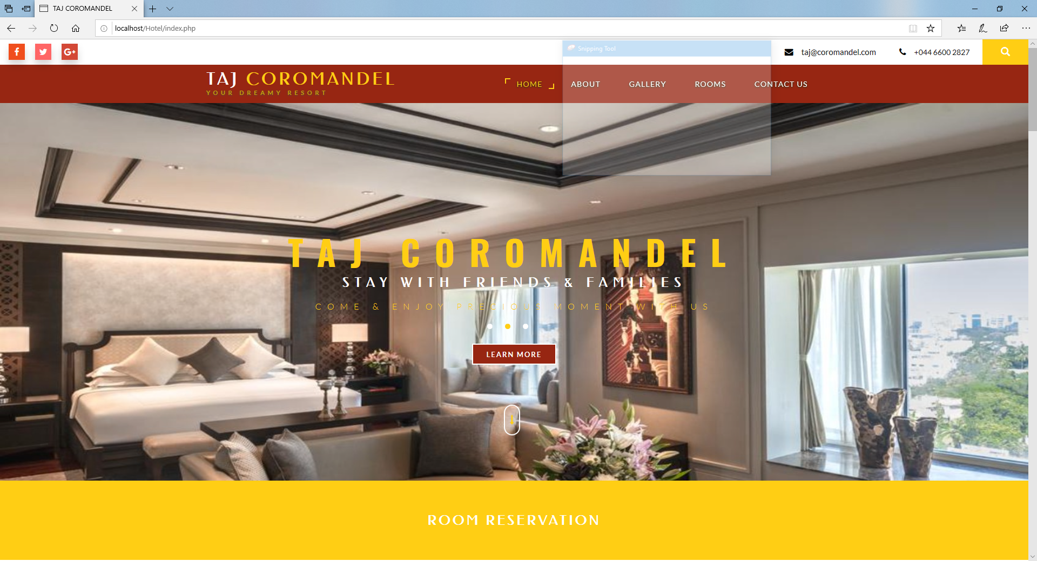

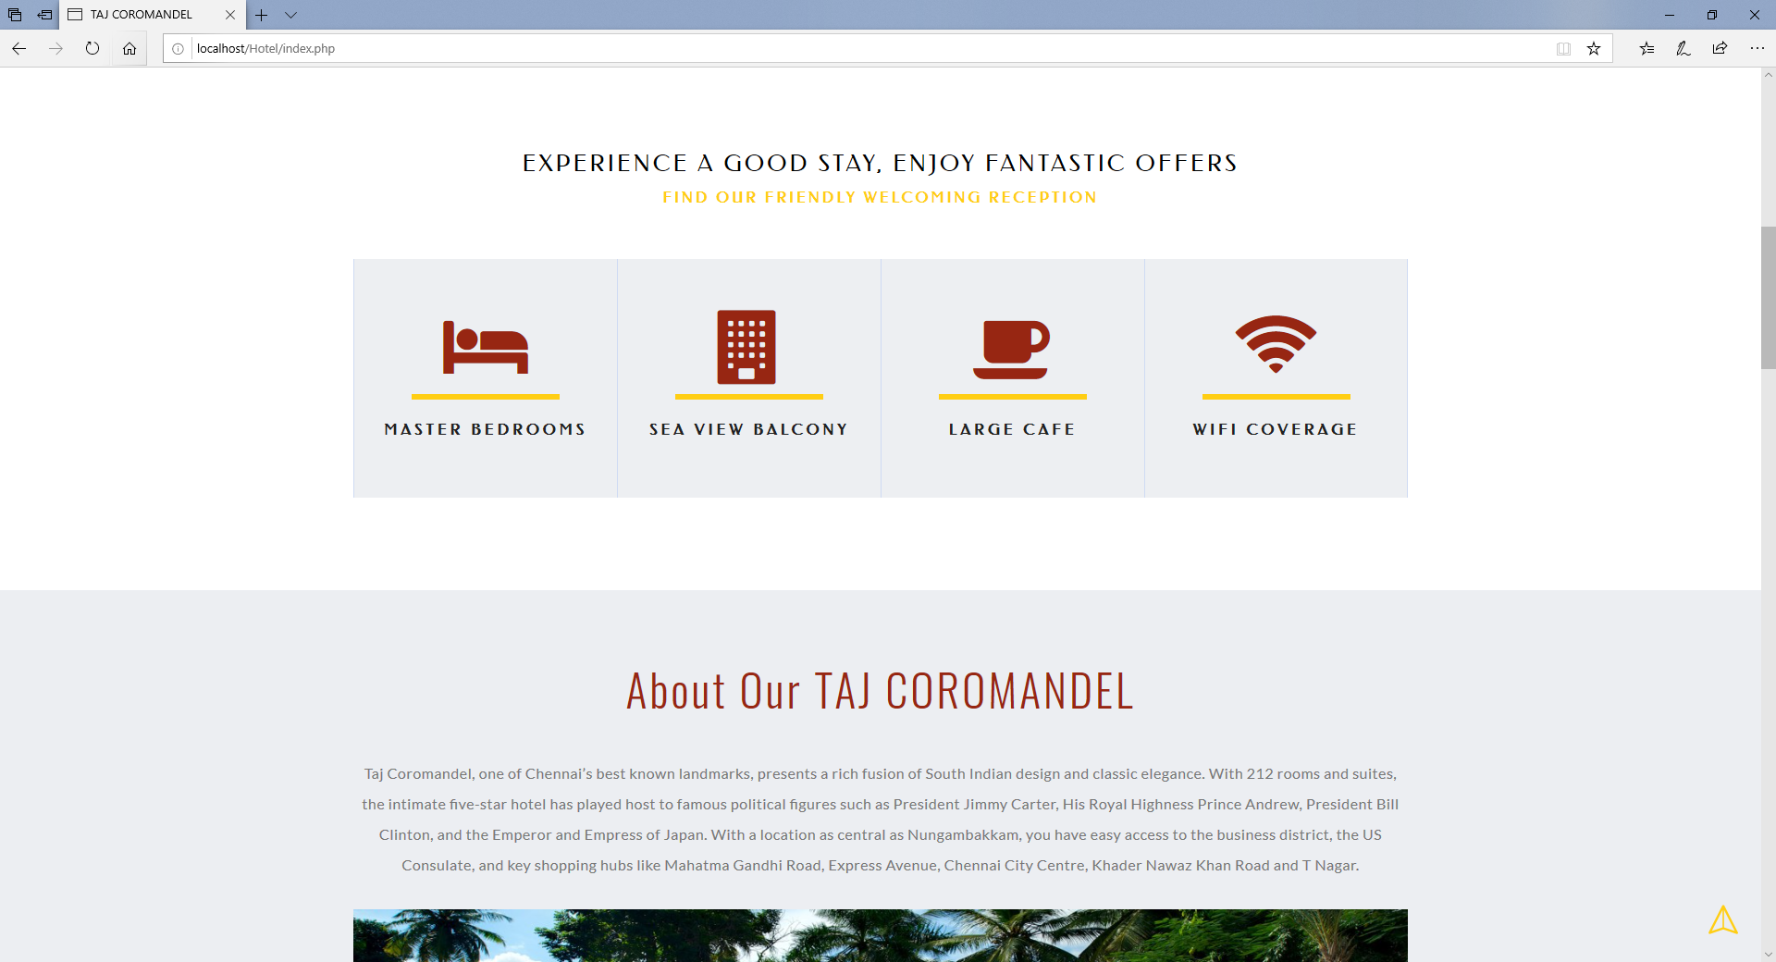

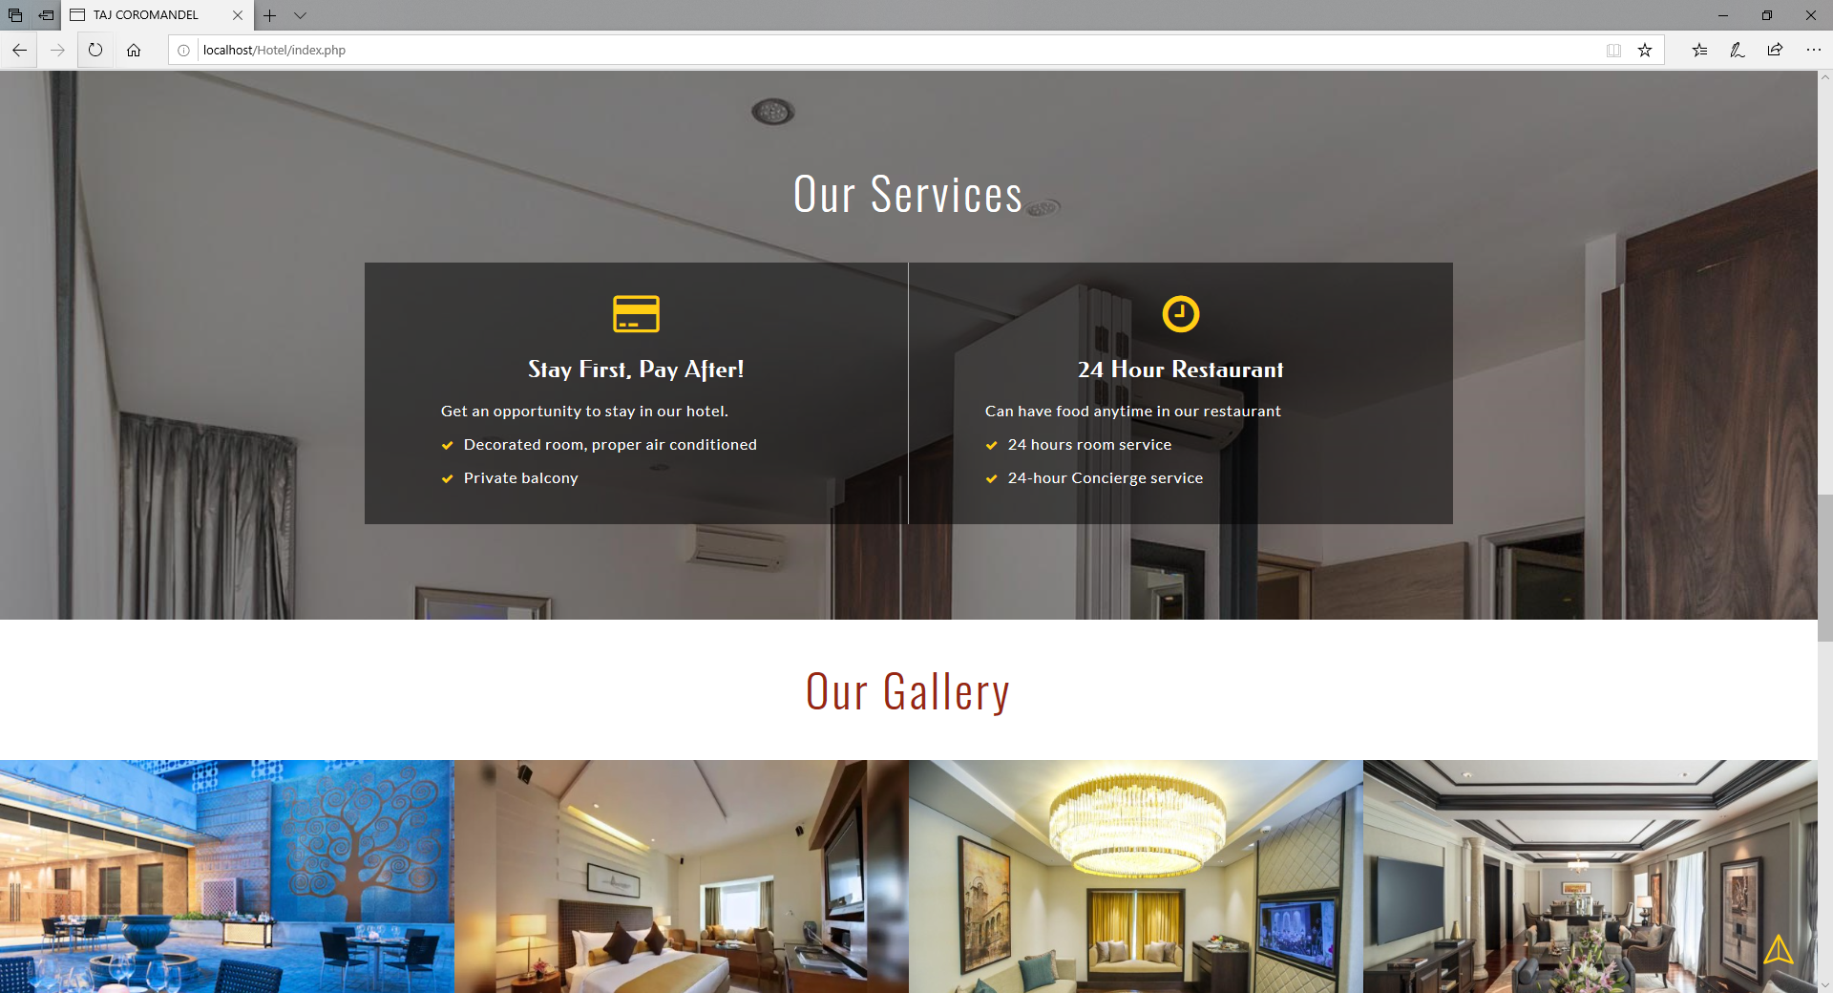

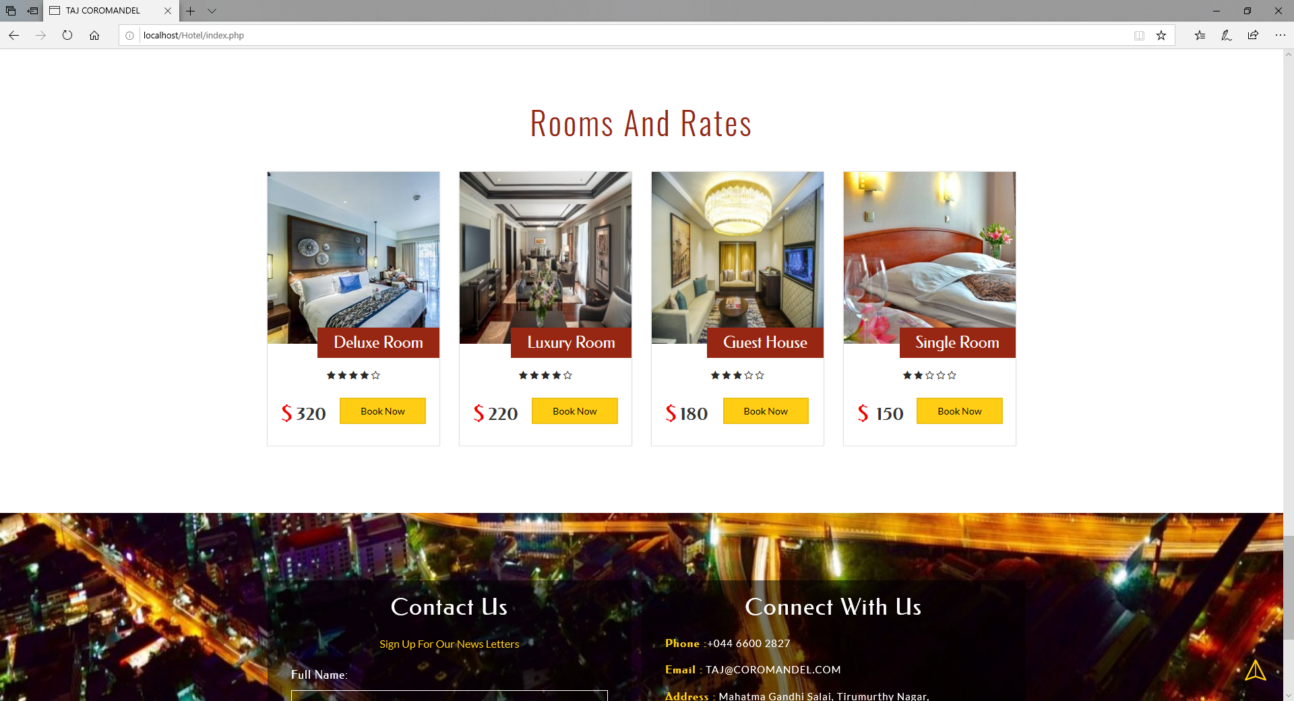

**Reservation page**

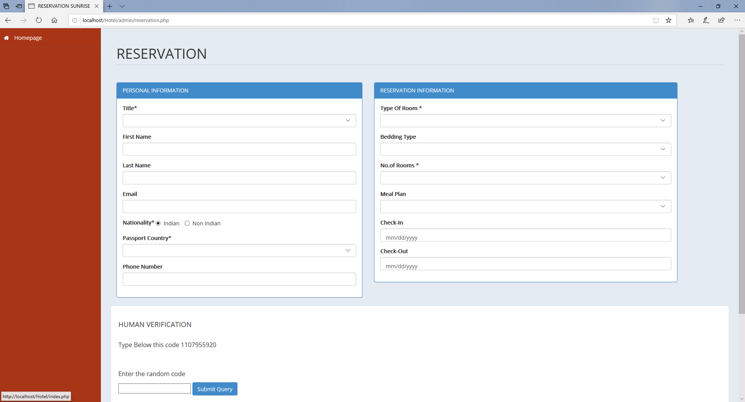

**Admim main page**

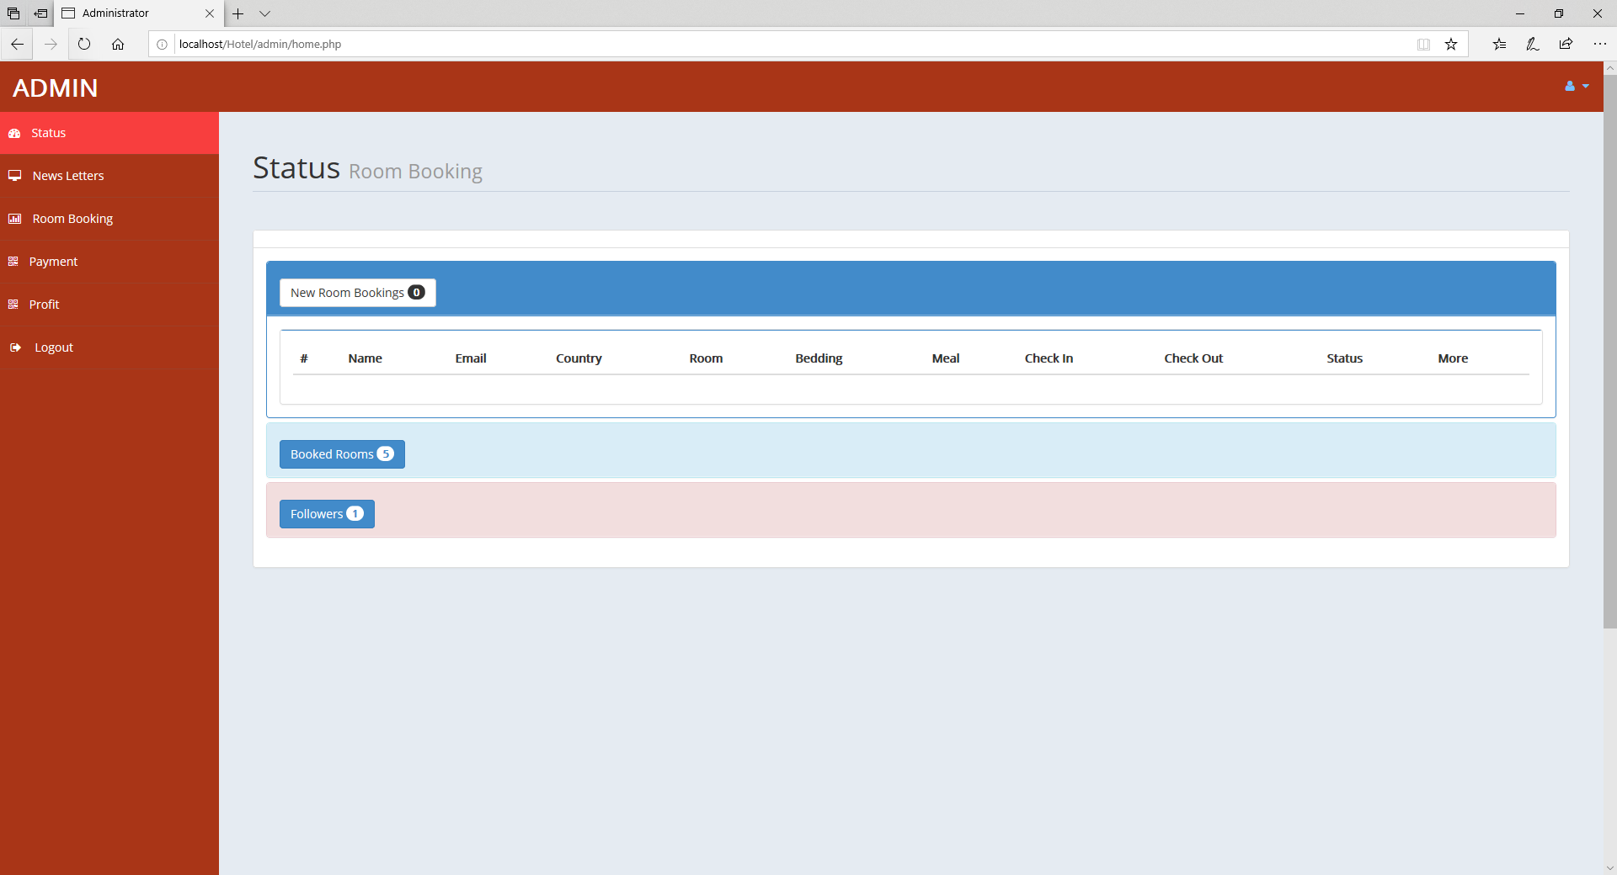

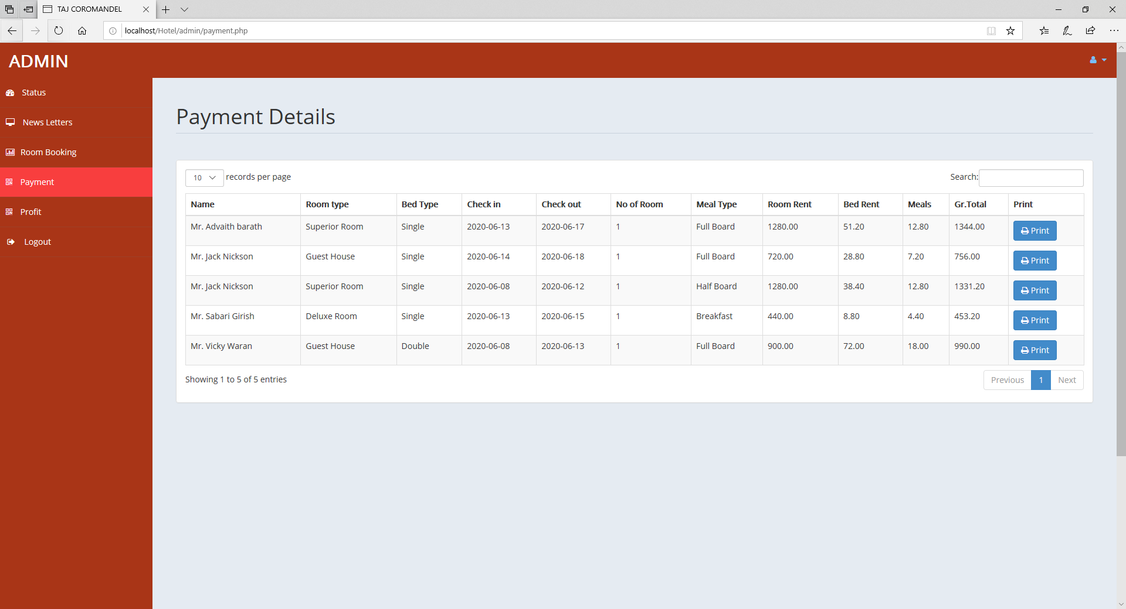

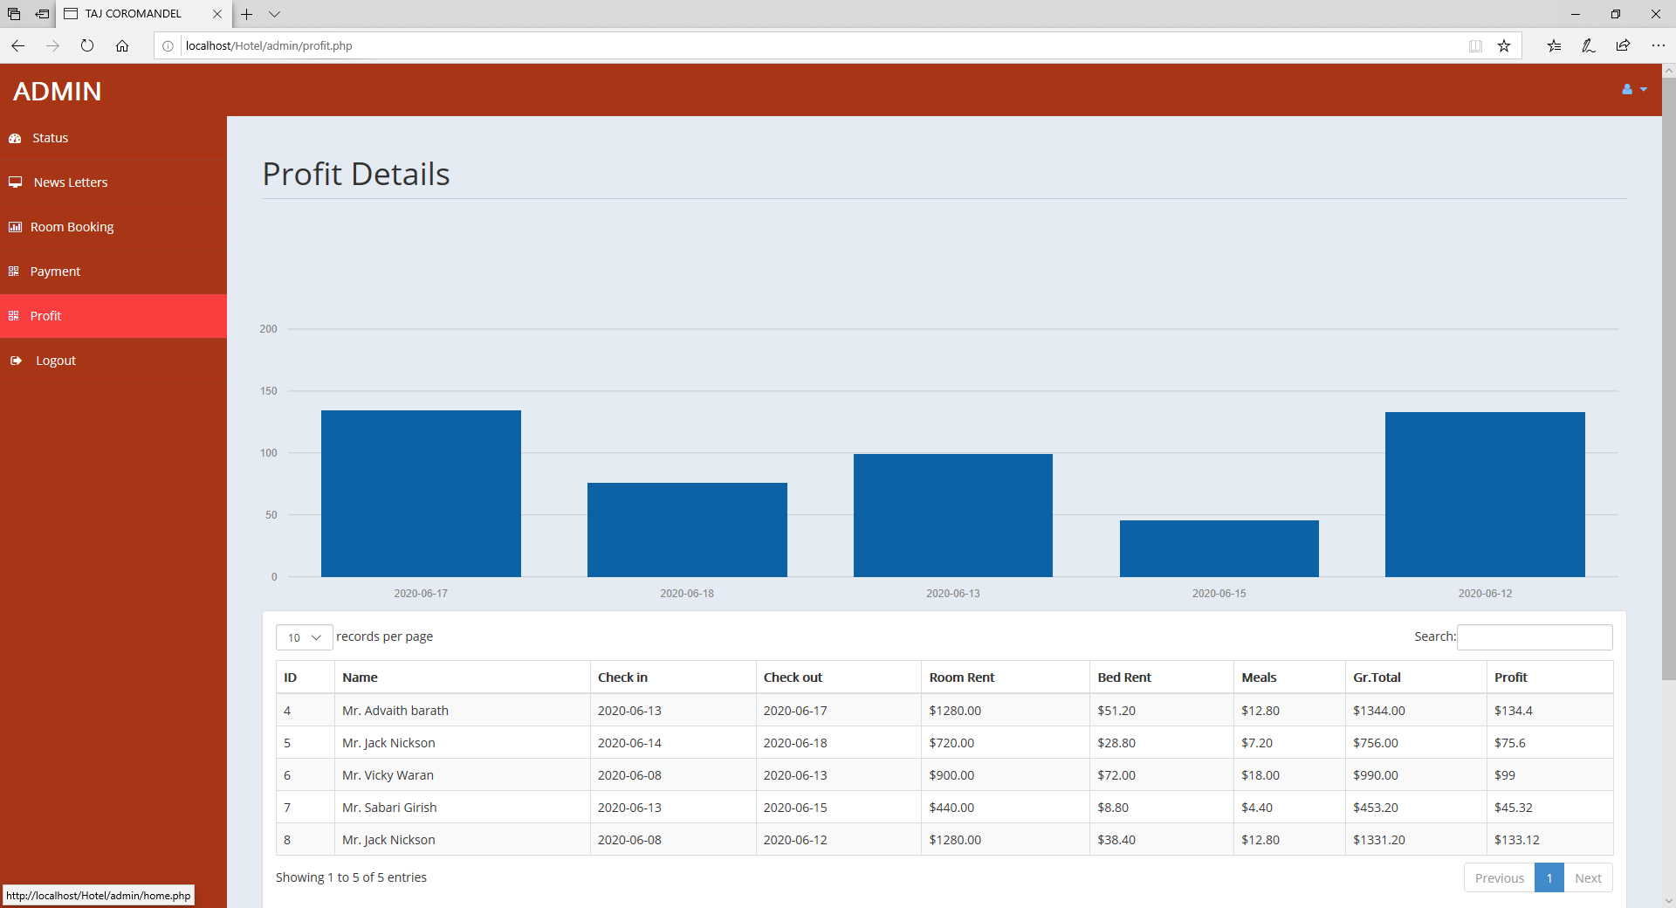

**9. CONCLUSION**

* We could able to create a main page that’s can attract more visitors
* Reservation and navigation are made more easier for hotel lookers
* Admins can monitor the number of people booked
* Admins can look at the statistics and monitor how much profit they had made
* Admins can manage and monitor no of room available for stay

**10. REFERENCES**

1. <https://www.phpjabbers.com/hotel-booking-system/#:~:text=The%20online%20hotel%20reservation%20system,impact%20conversions%20and%20increase%20bookings.>
2. <https://www.phptpoint.com/projects/hotel-reservation-system-project-php/>
3. <https://code-projects.org/online-hotel-reservation-system-in-php-with-source-code/>
4. <https://projectworlds.in/free-projects/php-projects/27772/>
5. <http://www.enggroom.com/Project-Abstract/Free%20Download%20Online%20Hotel%20Reservation%20Project%20in%20Php%20.htm>